Living Room Furniture – Coffee Tables

1. WHITE BLANC COFFEE TABLE:

OVERVIEW

"We used marbleized resin in our last collection, but this time we're doing it in a totally different way," says designer Kara Mann of this luxe coffee table. Solid resin with gorgeous white marbleized tones brings high-end vibes to the living room without the preciousness of real marble. CB2 exclusive.

DETAILS

* Designed by Kara Mann
* Solid white marbleized resin; activity will vary
* Clean with a soft, damp cloth; no abrasive cleaners
* A light application of quality furniture wax can be used
* Made in Vietnam

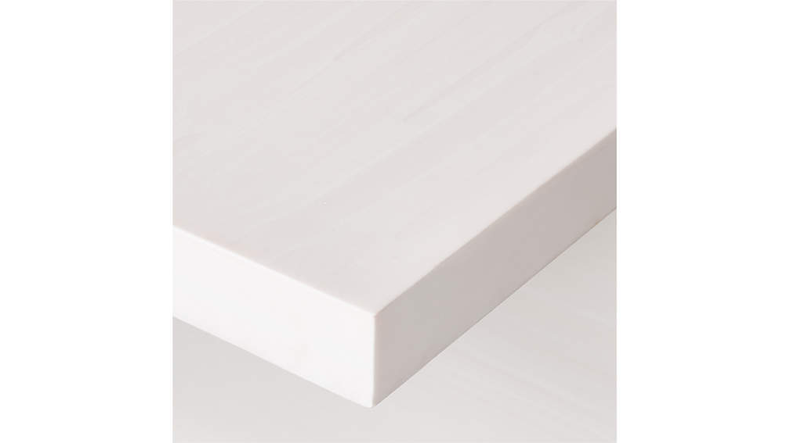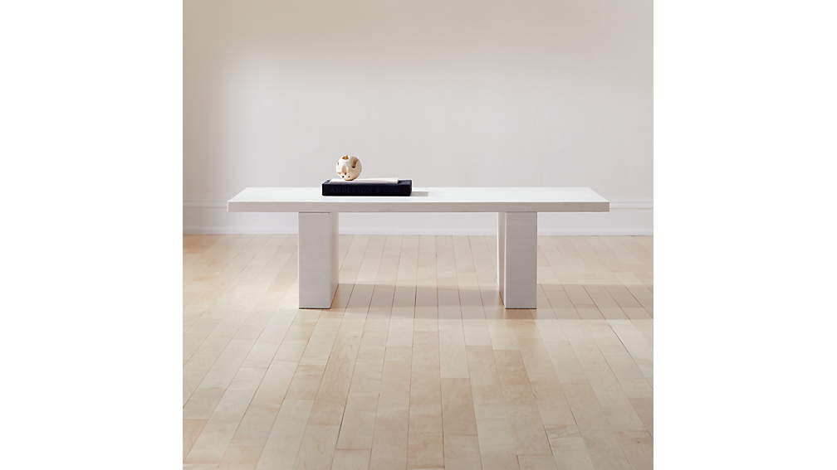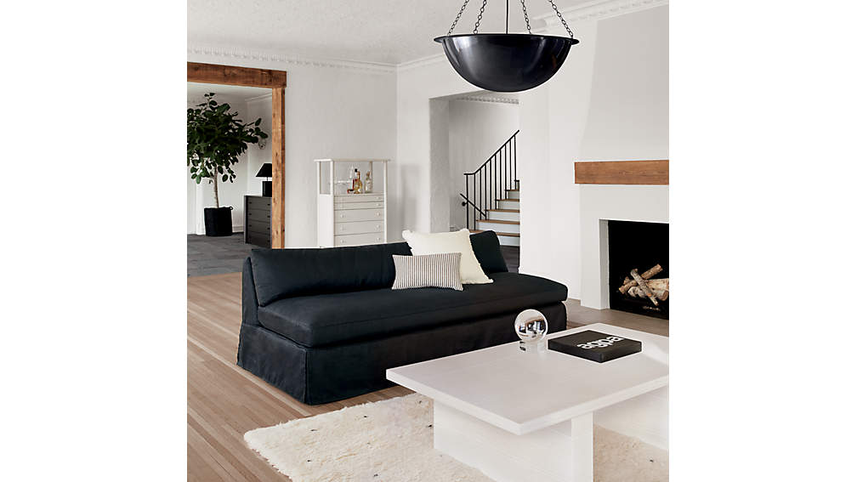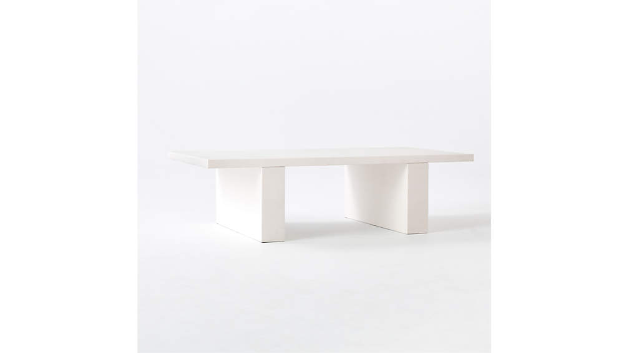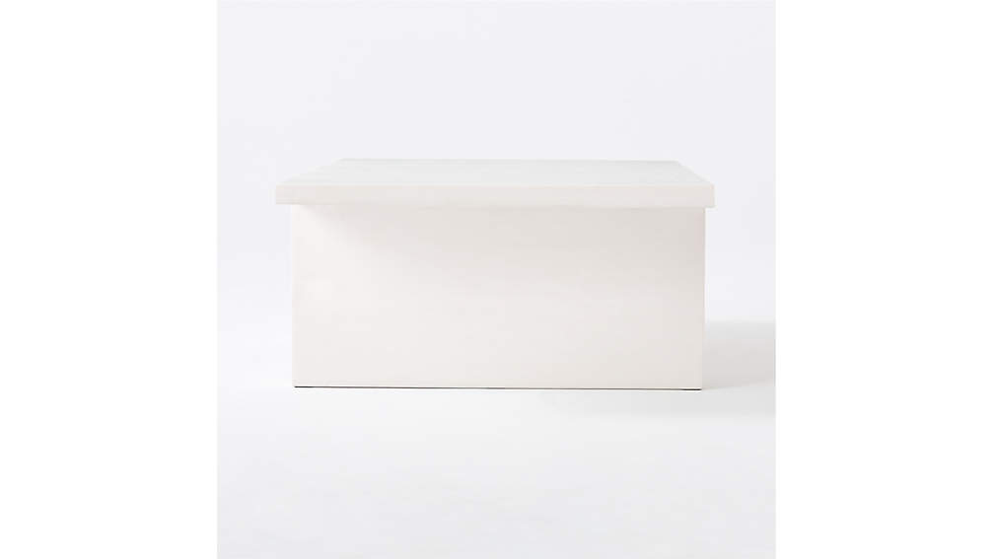

## DIMENSIONS

### DIMENSIONS FORCOATED RESIN COFFEE TABLE

##### **Overall Dimensions**

Width: 54"

Depth: 30"

Height: 15"

1. CANE GLASS COFFEE TABLE

Solid iron rod with lustrous black finish frames out this coffee table by designer Kara Mann. Topped with ultra-clear glass that practically disappears into the room, table strikes the perfect balance of adding personality to a room without taking over. Bronze cap feet add a final high-end touch. CB2 exclusive.

DETAILS

* Designed by Kara Mann
* Ultra-clear tempered glass top
* Solid iron rod with lustrous black finish
* Clean with a soft cloth
* Made in Taiwan

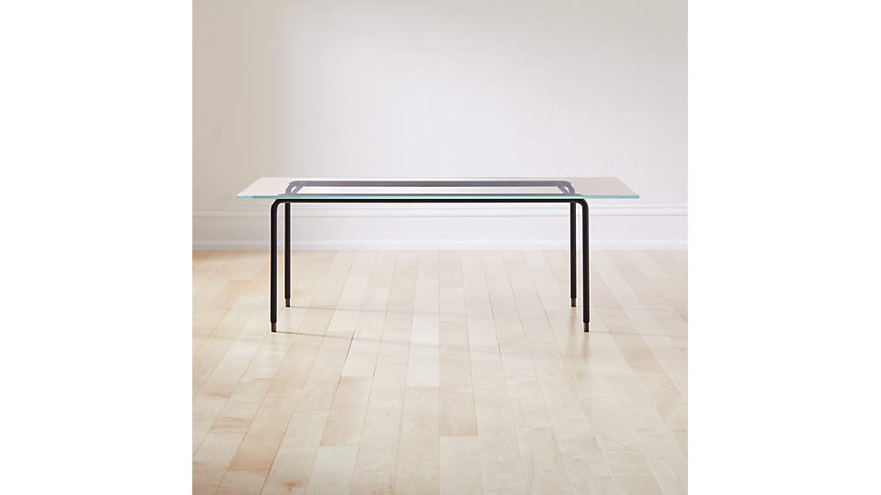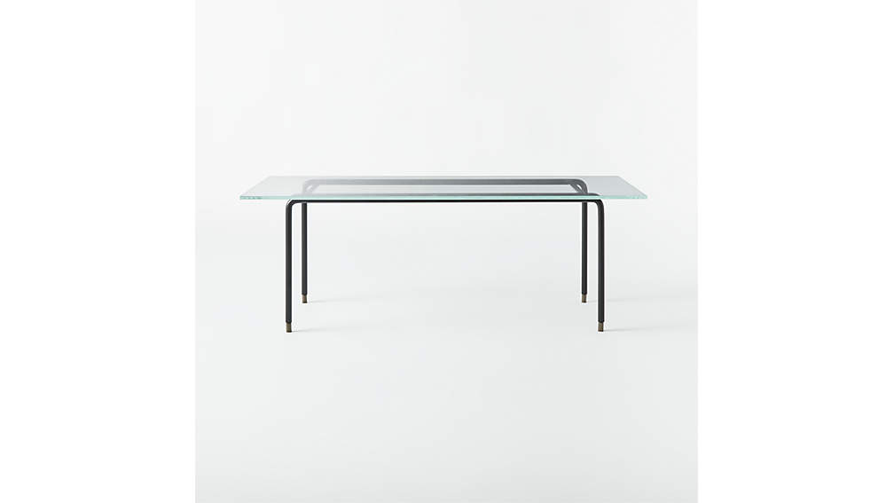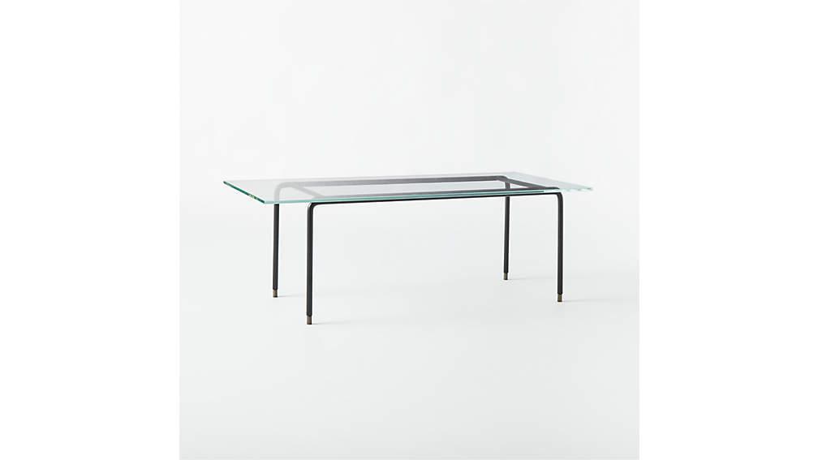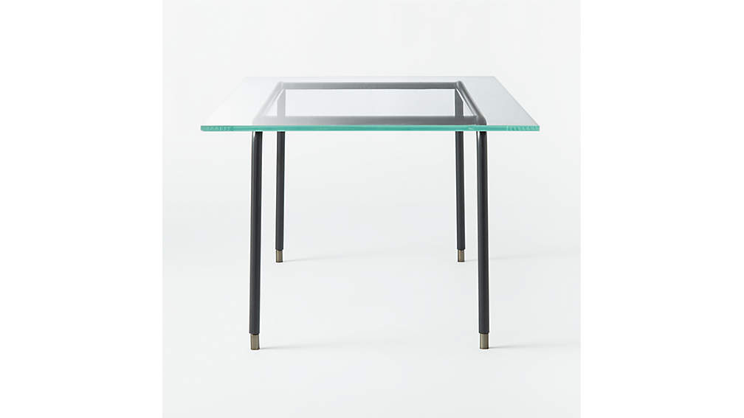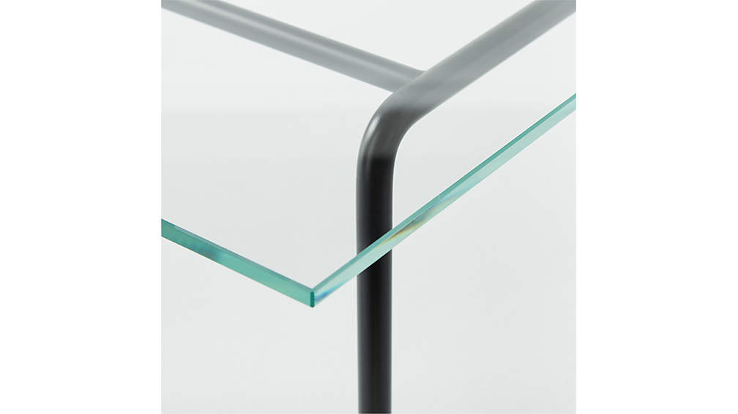

## DIMENSIONS

### DIMENSIONS FORCANE GLASS COFFEE TABLE

##### **Overall Dimensions**

Width: 45"

Depth: 22"

Height: 16"

1. CUT COFFEE TABLE

Modern, clean silhouette in warm ivory creates a fun, unexpected look in this coffee table by Kara Mann. It's finished in what we're calling "sprayed concrete," a matte lacquer that evokes real concrete yet is incredibly smooth to the touch. "The finish is really special and unique," says Kara. "I love the idea of this hard, tough material done in a delicate way. It almost feels like porcelain to me." CB2 exclusive.

DETAILS

* Designed by Kara Mann
* Solid poplar and engineered wood base with sprayed white concrete finish
* White glass
* Clean with a soft cloth; no abrasive cleaners
* Made in Vietnam

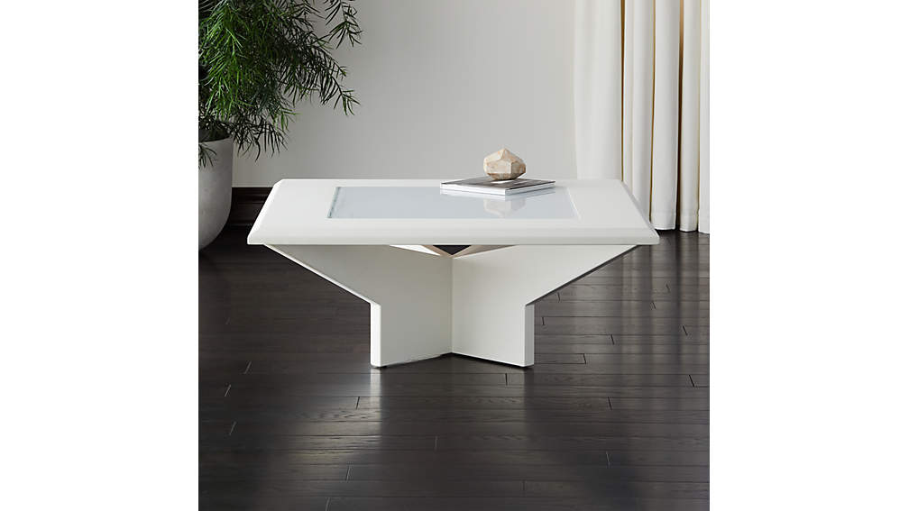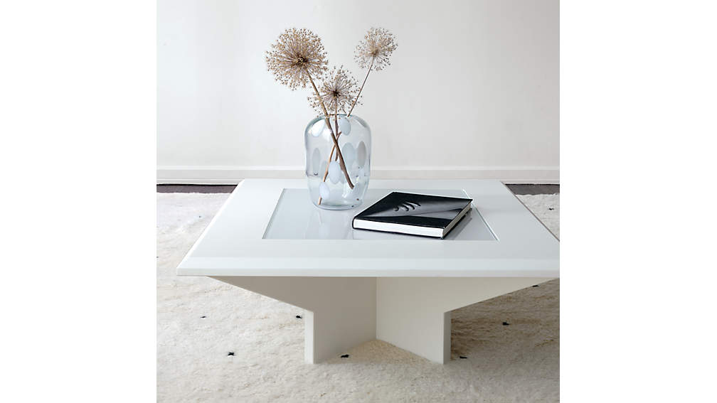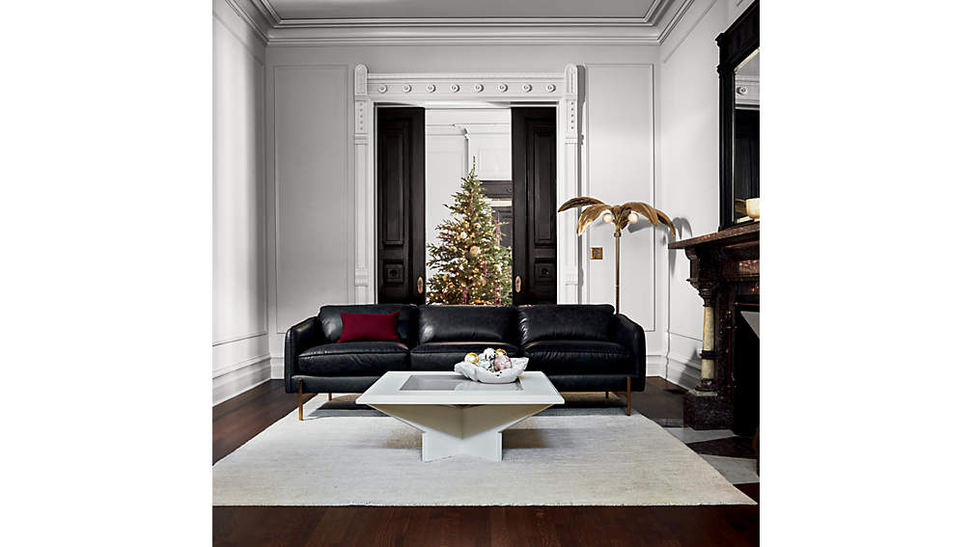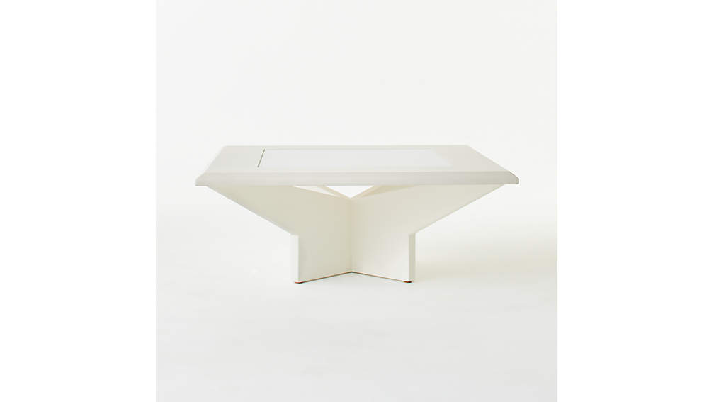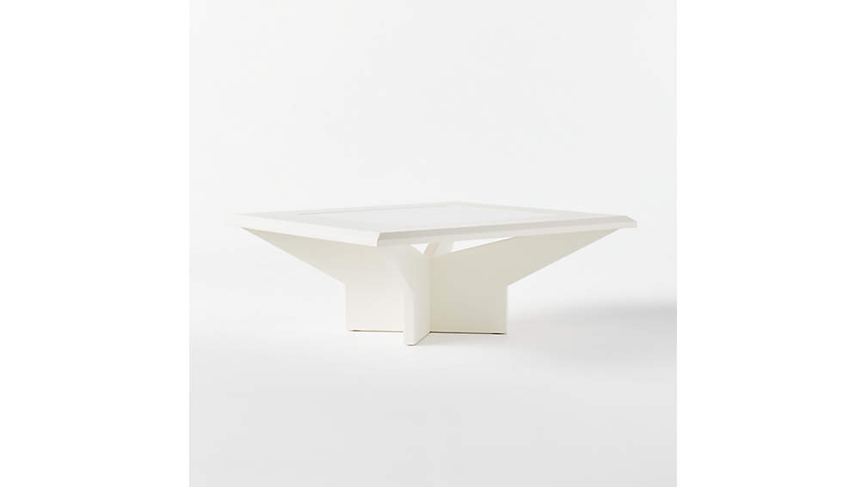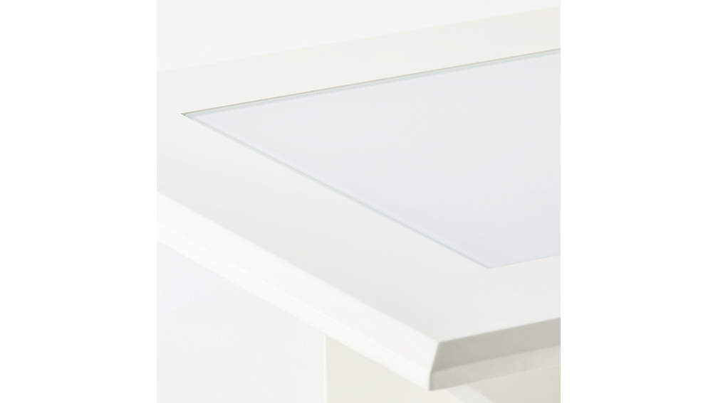

## DIMENSIONS

### DIMENSIONS FORCUT COFFEE TABLE

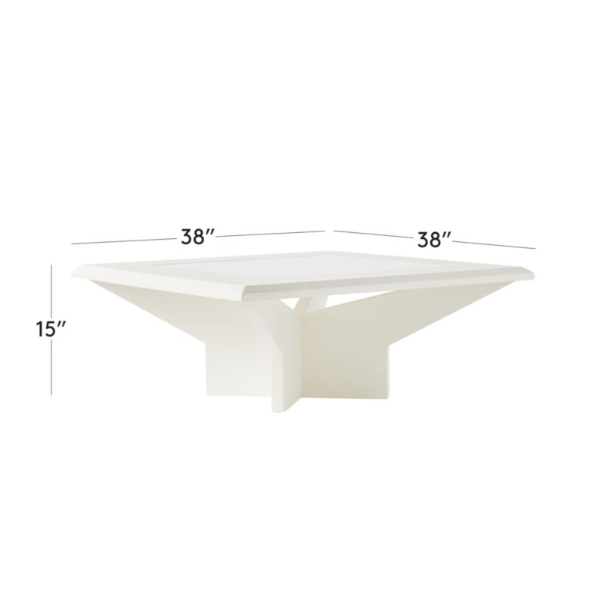

##### **Overall Dimensions**

Width: 38"

Depth: 38"

Height: 15"

1. MUSE MIRROR COFFEE TABLE

"To me, this is the ultimate party table," explains designer Kara Mann. "The mirrored base, the oversized glass top—it's so cool, so chic, so understated." Ultra clear glass top practically disappears into the room, while the mirrored base and angular lines bring a vibrant, showstopping quality. CB2 exclusive.

DETAILS

* Designed by Kara Mann
* Engineered wood base with mirrored glass
* Ultra clear tempered glass top
* Clean with a soft cloth; no abrasive cleaners
* Made in Taiwan

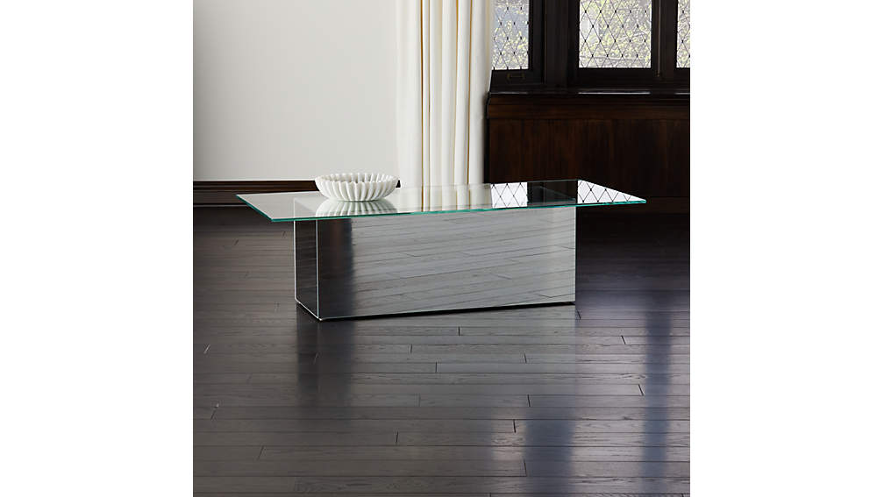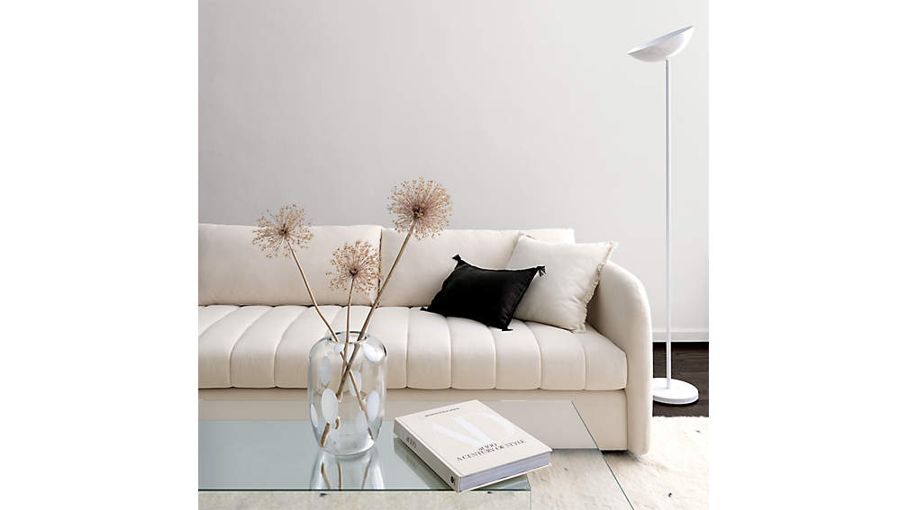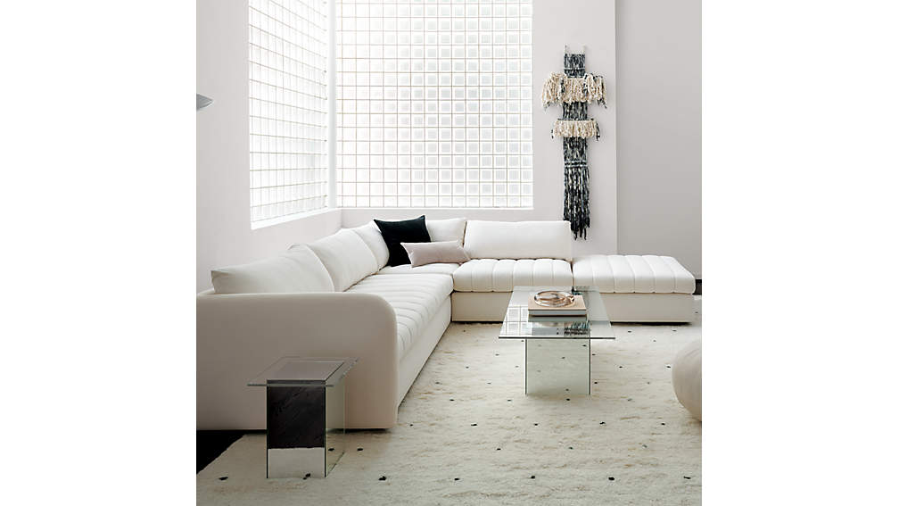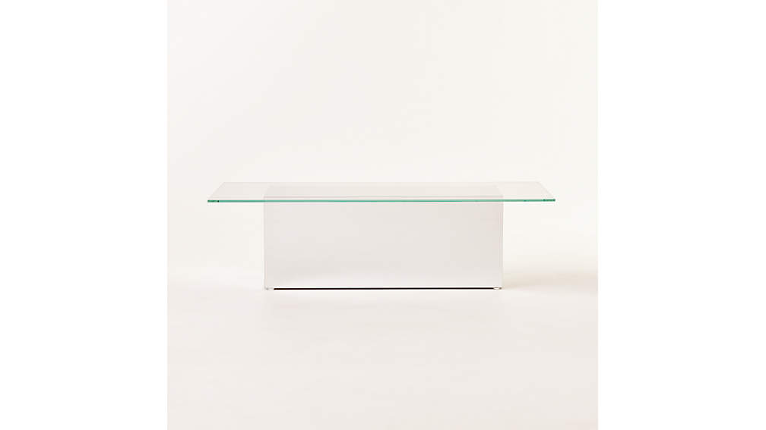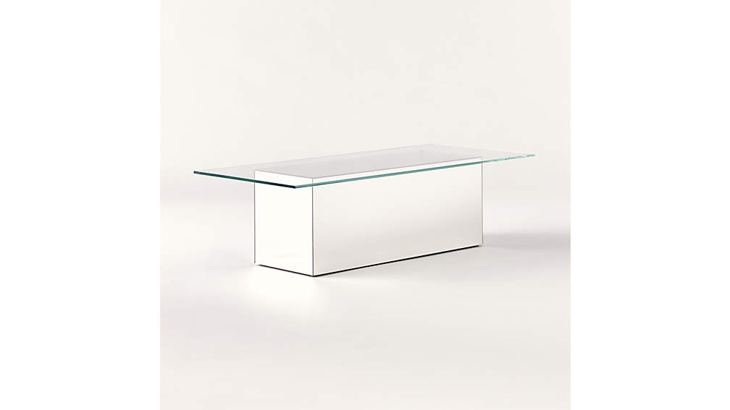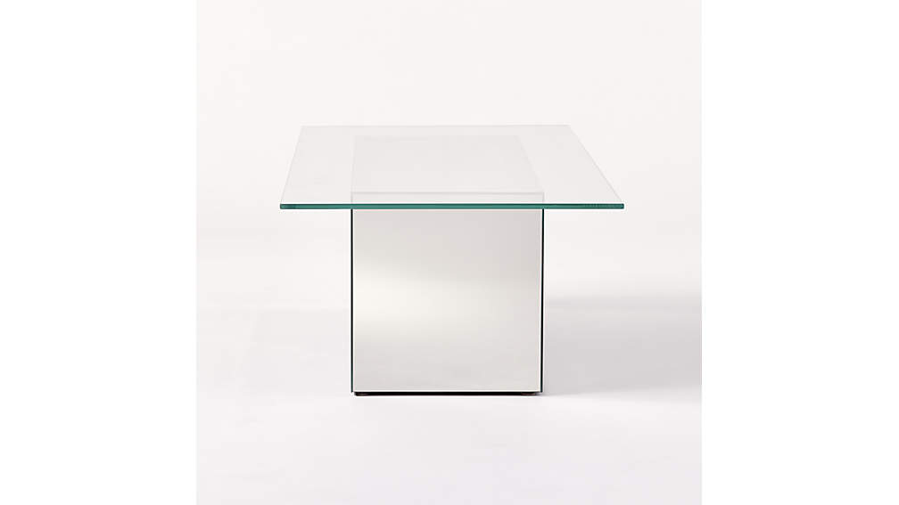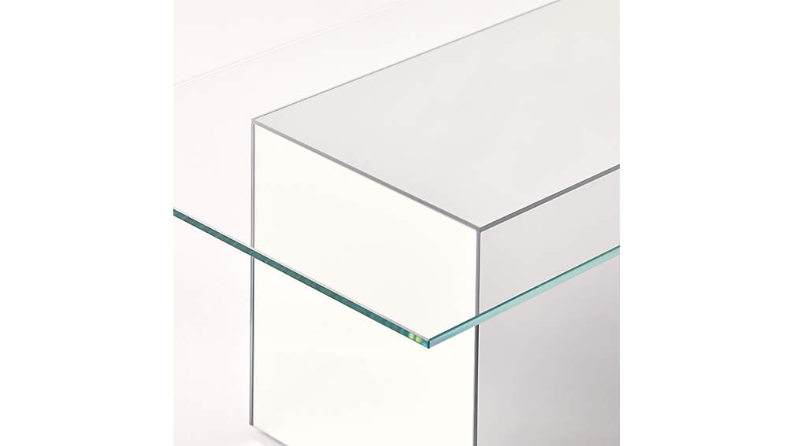

## DIMENSIONS

### DIMENSIONS FORMUSE MIRROR COFFEE TABLE

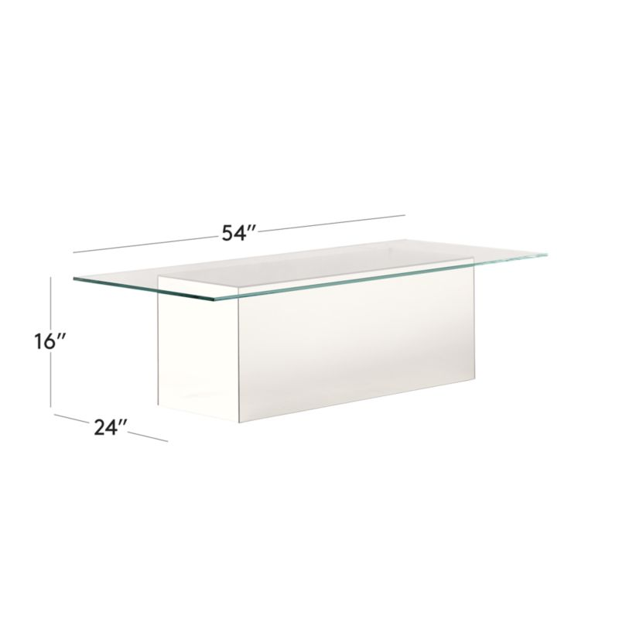

##### **Overall Dimensions**

Width: 54"

Depth: 24"

Height: 16"

1. SLOPE COFFEE TABLE

Stunning white coffee table makes a statement in any living room. Soft curves push against hard edges creating a harmonious juxtaposition you might find in a sculpture gallery. Organic yet refined, this is one of those pieces that instantly elevates any space. Learn about [Nicholas Obeid](https://www.cb2.com/blog/nicholas-obeid/) on our blog. CB2 exclusive.

DETAILS

* Designed by Nicholas Obeid
* Natural white concrete
* Each will be unique
* Coasters recommended
* Made in Vietnam

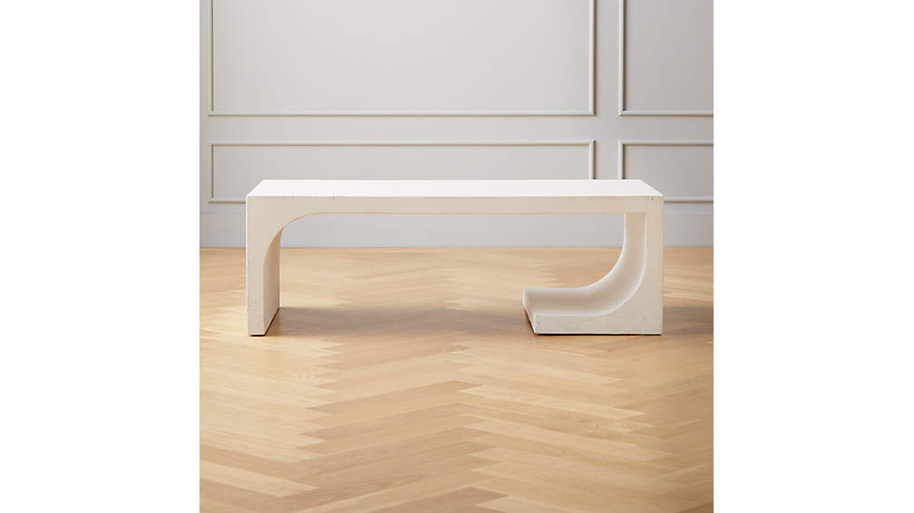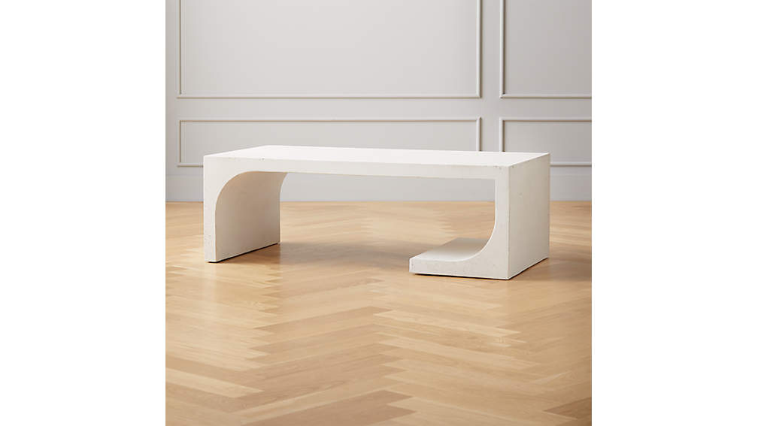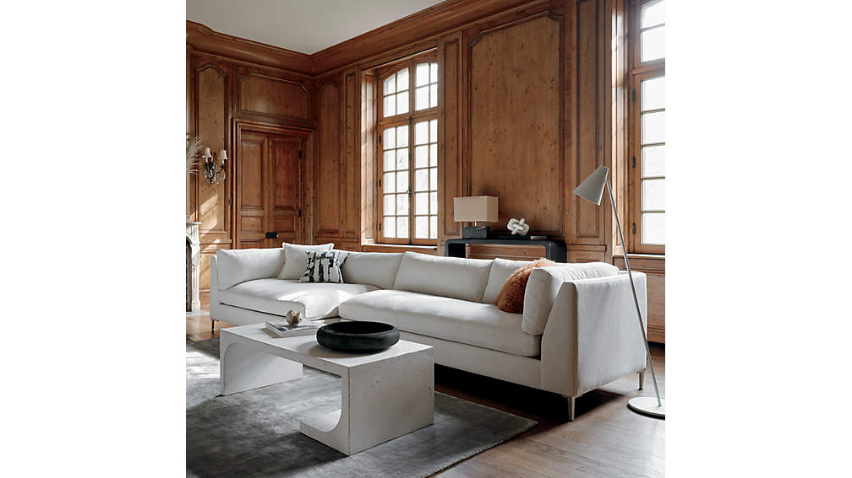

## DIMENSIONS

### DIMENSIONS FORSLOPE CEMENT COFFEE TABLE

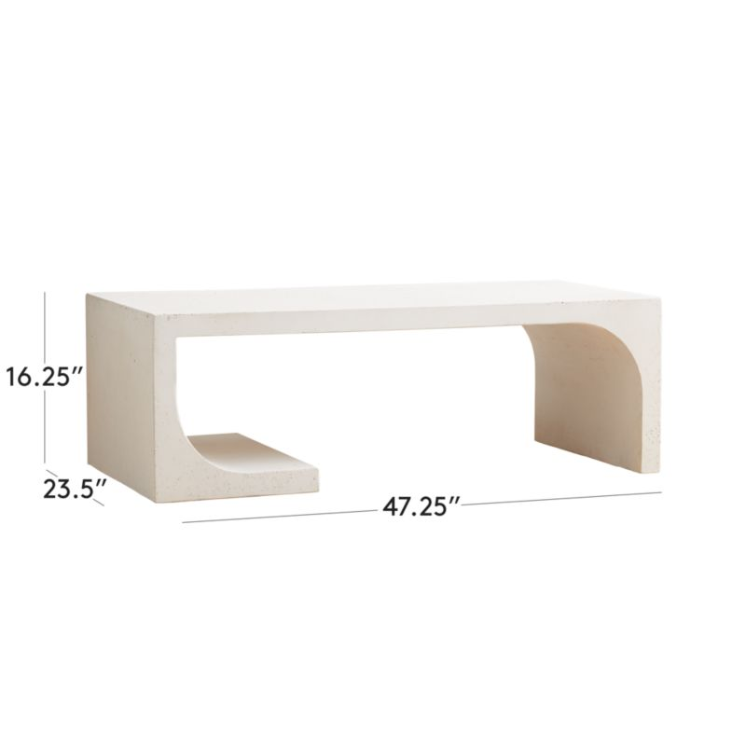

##### **Overall Dimensions**

Width: 47.75"

Depth: 23.5"

Height: 16.25"

1. HORSESHOE LACQUERED WHITE RECTANGULAR COFFEE TABLE:

Inspired by the modern silhouettes and unique materials of the 1970s, VUUE's design transforms a simple U-shape into a statement coffee table with extra-rich texture. Raffia wraps the piece, finished in hi-gloss ivory. Mixes effortlessly with any modern living situation. Learn about [VUUE](https://www.cb2.com/blog/ceci-thompson/) on our blog. CB2 exclusive.

DETAILS

* Designed by VUUE
* Engineered wood with raffia, finished in hi-gloss ivory
* Each will be unique
* Coasters recommended
* Made in Vietnam

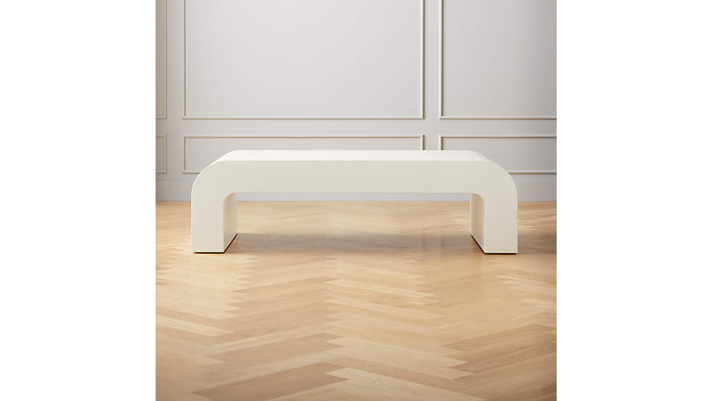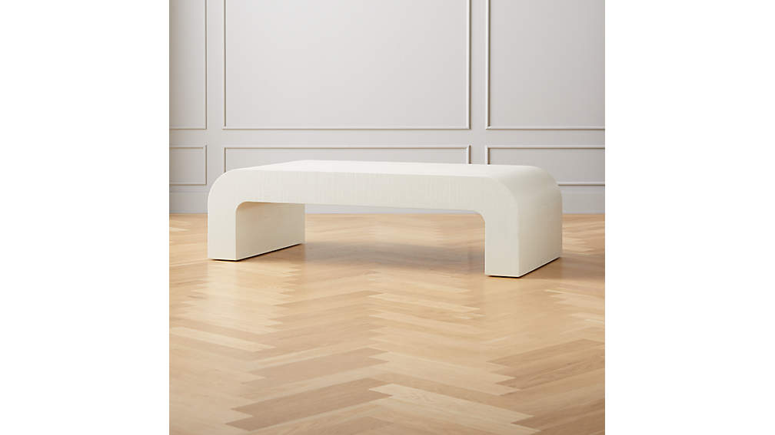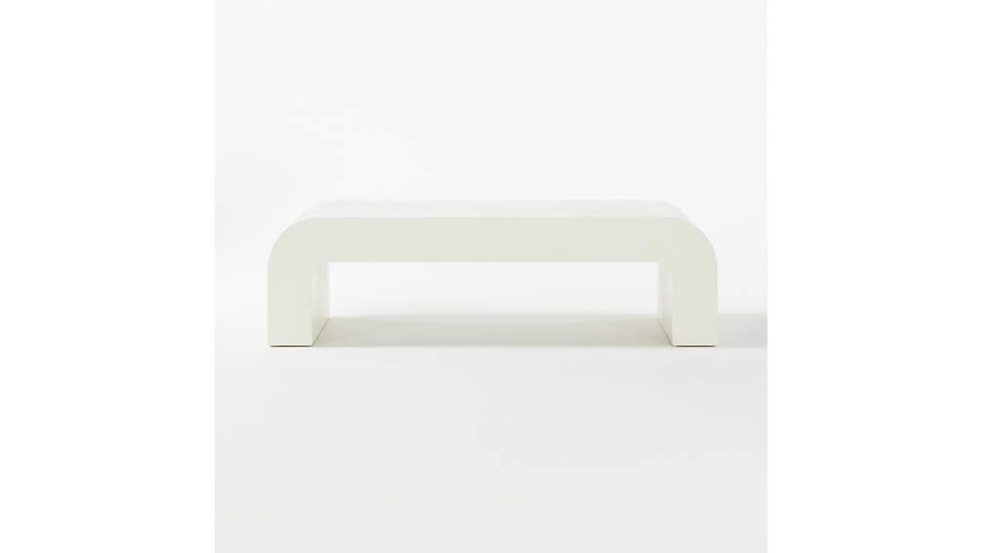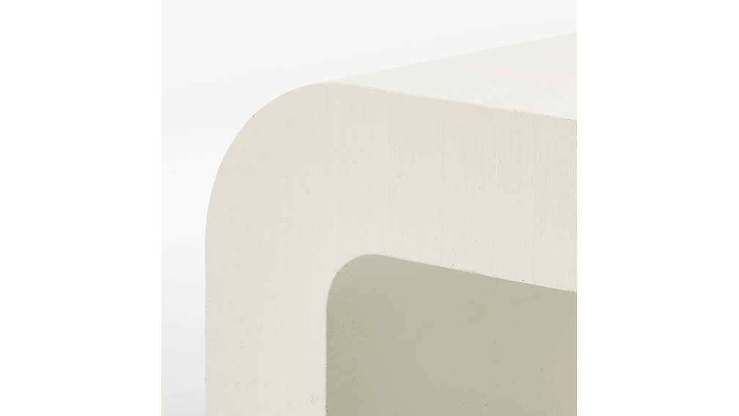

## DIMENSIONS

### DIMENSIONS FORHORSESHOE IVORY LACQUERED LINEN RECTANGULAR COFFEE TABLE

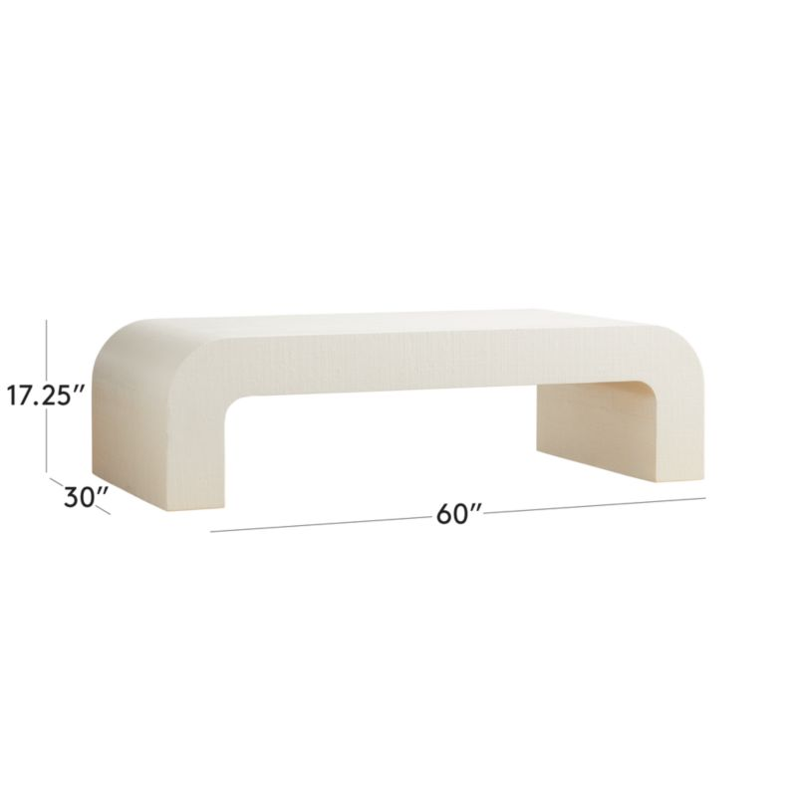

##### **Overall Dimensions**

Width: 60"

Depth: 30"

Height: 17.25"

1. Smart Brass Coffee Table with Marble Top:

Black marble slab tops off open cylinder construction of brass-plated steel. Sitting at just 12" tall, low-profile coffee table is both smooth and cool no matter the room. Totally customizable: top or base can be swapped out for a whole new look. CB2 exclusive.

DETAILS

* Black Marquina marble top with white veining
* Steel tube frame with a brass-plated finish
* Clean with a soft cloth
* Protect marble from liquids; wipe up spills immediately
* Coasters recommended
* Made in Taiwan

## DIMENSIONS

### DIMENSIONS FORSMART BRASS COFFEE TABLE WITH BLACK MARBLE TOP

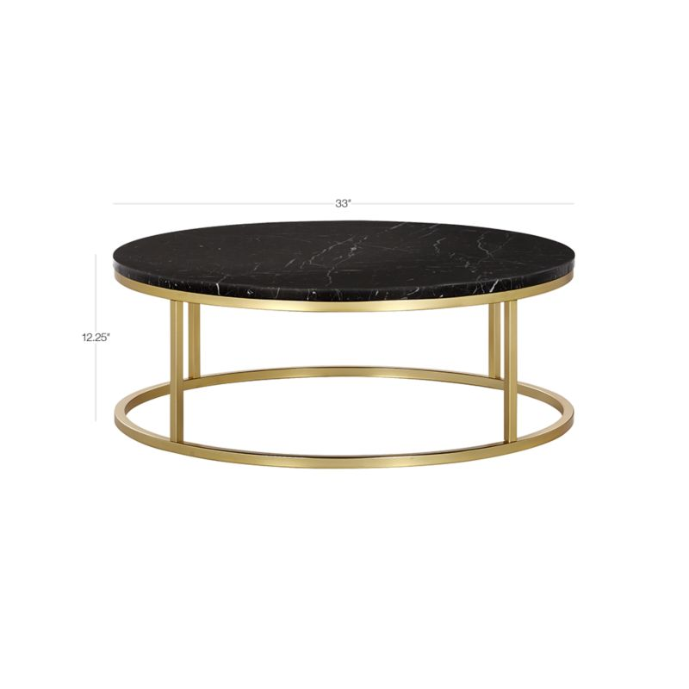

##### **Overall Dimensions**

Height: 12.25"

Diameter: 33"

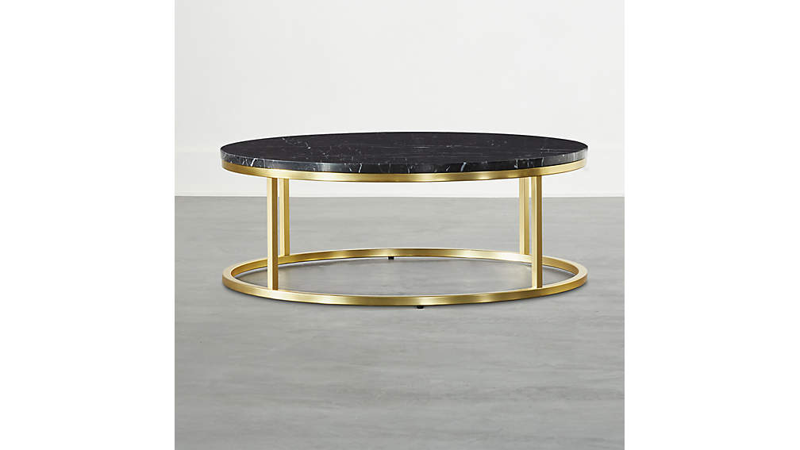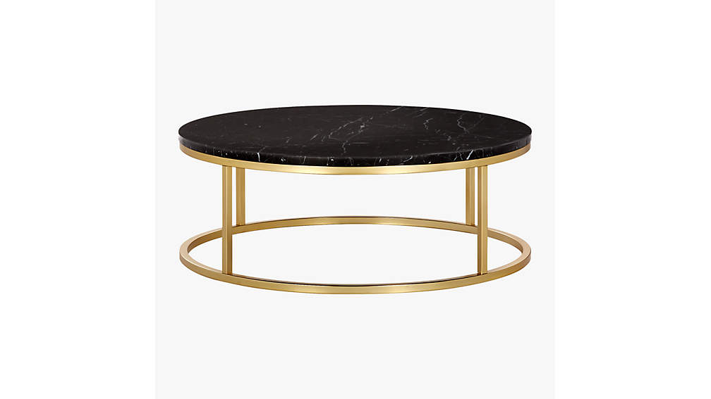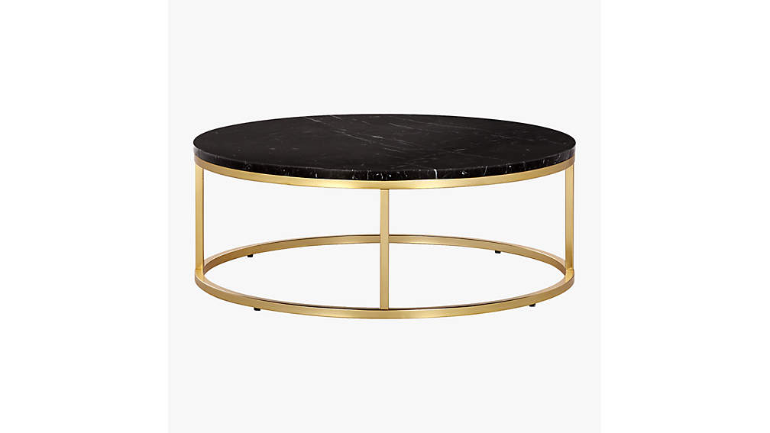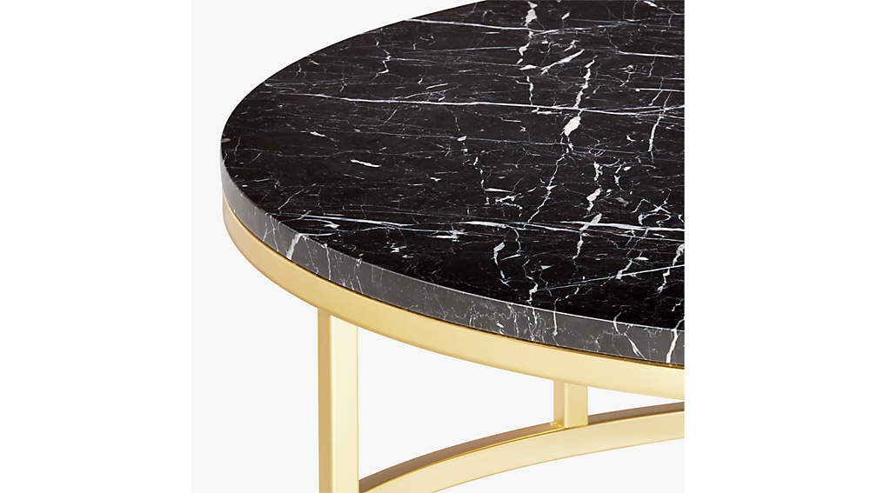

Black marble slab tops off open cylinder construction of chrome-plated steel. Low-profile coffee table sits at just 12" tall and rounds out any room in a sleek, dramatic way. Completely customizable: top or base can be swapped out for a whole new look. CB2 exclusive.

DETAILS

* Black Marquina marble top with white veining
* Steel tube frame with a chrome-plated finish
* Clean with a soft cloth
* Protect marble from liquids; wipe up spills immediately
* Coasters recommended
* Made in Taiwan

## DIMENSIONS

### DIMENSIONS FORSMART CHROME COFFEE TABLE WITH BLACK MARBLE TOP

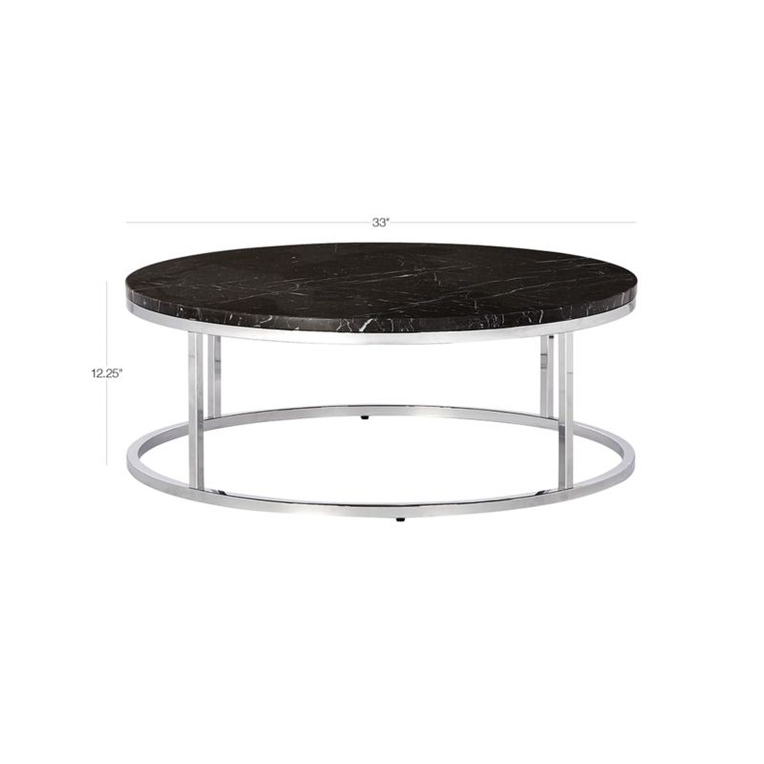

##### **Overall Dimensions**

Height: 12.25"

Diameter: 33"

Open cylinder construction of matte black steel topped with a Carrara-style white/grey slab. Low-profile coffee table rides just 12" off the floor and has an industrial-inspired quality to it. Fully customizable: top or base can be swapped out for a whole new look. CB2 exclusive.

DETAILS

* Carrara-style white marble top with grey veining
* Steel tube frame with a matte black finish
* Clean with a soft cloth
* Protect marble from liquids; wipe up spills immediately
* Coasters recommended
* Made in Taiwan

## DIMENSIONS

### DIMENSIONS FORSMART BLACK COFFEE TABLE WITH WHITE MARBLE TOP

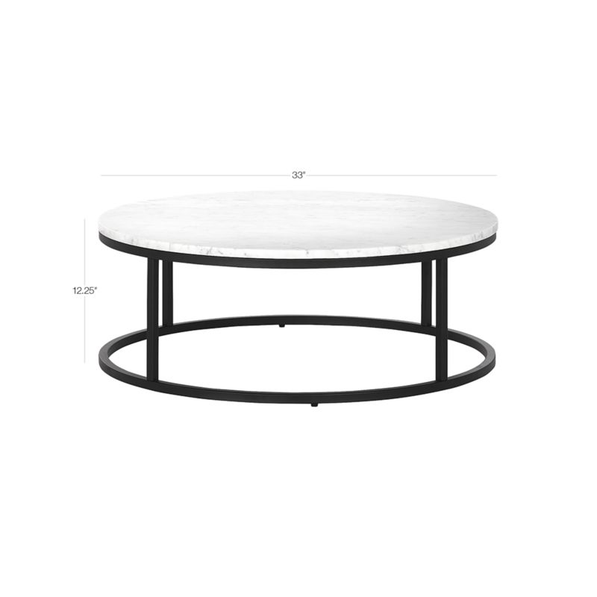

##### **Overall Dimensions**

Height: 12.25"

Diameter: 33"

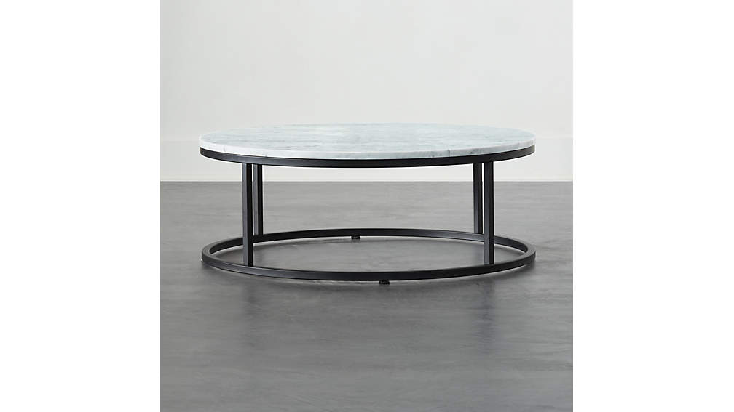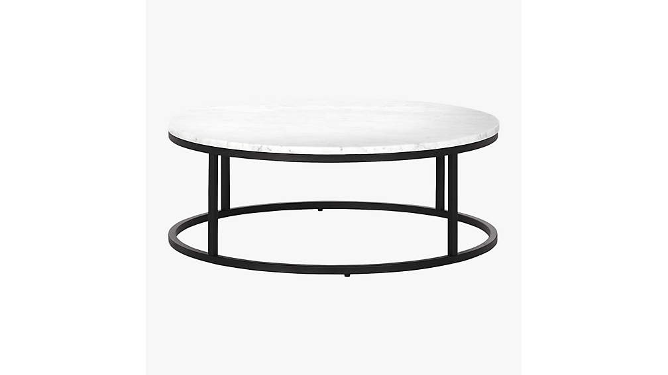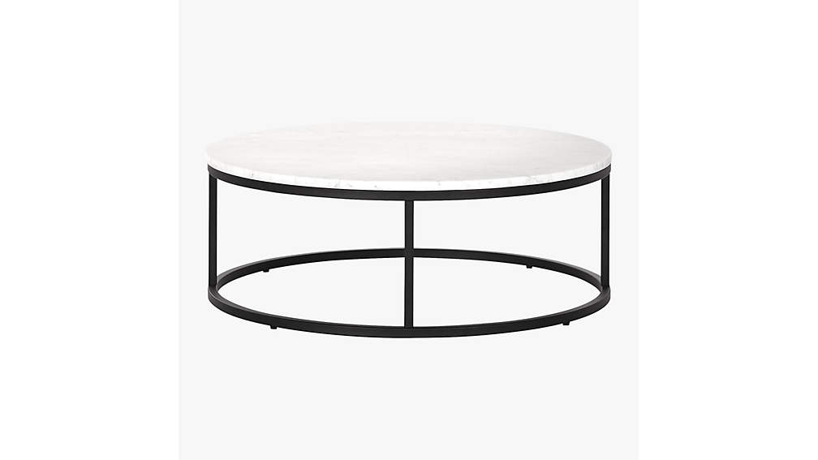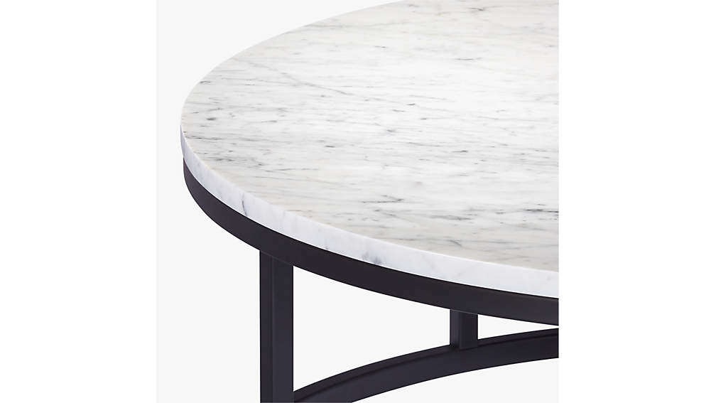

1. SMART ROUND COFFEE TABLE WITH BLACK MARBLE TOP

Black marble slab tops off open cylinder construction of matte black steel. Low-profile and sleek, this marble coffee table sits at just 12" tall and adds dramatic vibes to any style. Entirely customizable: top or base can be swapped out for a whole new look. CB2 exclusive.

## DETAILS

* Black Marquina marble top with white veining
* Steel tube frame with a matte black finish
* Clean with a soft cloth
* Protect marble from liquids; wipe up spills immediately
* Coasters recommended
* Made in Taiwan

PRINTTHIS PAGE

EMAILA LINK TO THIS PAGE TO SOMEONE

## DIMENSIONS

### DIMENSIONS FORSMART ROUND BLACK MARBLE COFFEE TABLE

##### **Overall Dimensions**

Height: 12.25"

Diameter: 33"